Indoor monitor

Model No.A1S-801ZCD8S9
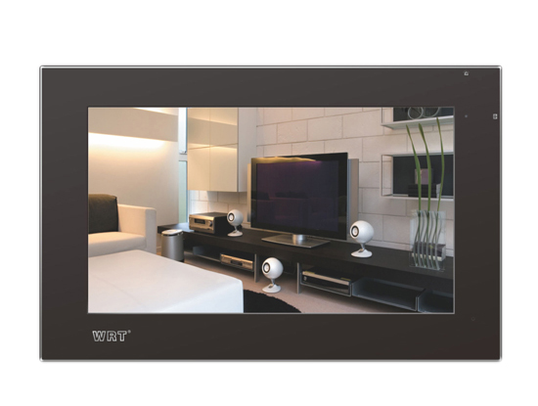
Features:

1.9.0" TFT-LCD digital touch screen,can monitor entrance,outdoor situation anytime and work with a door camera for a second calling.
2. Remote unlocking
3. Directly call can talk with center unit,and send alarm information.
4. Call any other indoor unit in LAN system
5. Download chord ring tones from management center PC and setup mute status.
6. Call elevator
7. Call divert to guard center
8. Household appliance control
9. Support voice,pictures,message checking function
10.Accept service from center unit
11.Max 4 indoor units work together
12. Support remote upgrading function

Specifications:
Input voltage: +DC18V
Working Humidity：45%--95%
Storage temperature：-15—55℃
LCD: 9" TFT-LCD
Sensitivity：≤20mV

Distortion：≤5％
Display Pixel：384000dots
Working Current：≤350mA±20%
Quiescent current：≤200mA±20%
Output power:≥50mW
Video transmission: 75Ω cable
Display time：about 60 S
Network port：RJ45
Network transmission mode：TCP\IP
Transmission range: router or PBX less than 100m, FOT more than 100m



